**Aim: Use (a) Linear Layout (b) Relative Layout and (c) Grid Layout or Table Layout**

1. **Linear Layout**

activity_main.xml:

<?xml version="1.0" encoding="utf-8"?>

<LinearLayout xmlns:android="http://schemas.android.com/apk/res/android"

android:layout_width="match_parent"

android:layout_height="match_parent"

android:paddingLeft="16dp"

android:paddingRight="16dp"

android:orientation="vertical" >

<EditText

android:layout_width="match_parent"

android:layout_height="wrap_content"

android:hint="@string/app_name" />

<EditText

android:layout_width="match_parent"

android:layout_height="wrap_content"

android:hint="@string/app_name" />

<EditText

android:layout_width="match_parent"

android:layout_height="0dp"

android:layout_weight="1"

android:gravity="top"

android:hint="@string/app_name" />

<Button

android:layout_width="100dp"

android:layout_height="wrap_content"

android:layout_gravity="right"

android:text="@string/app_name" />

</LinearLayout>

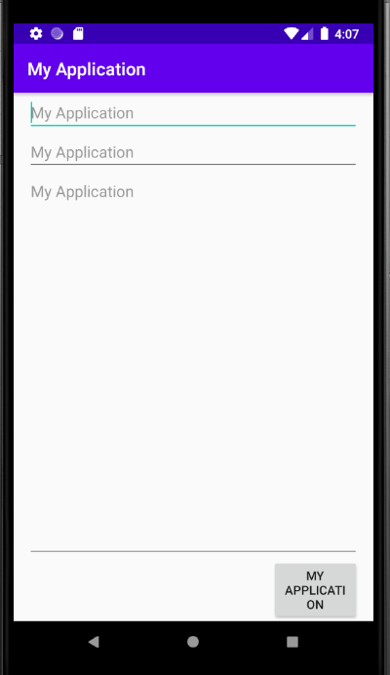

**(b) Relative Layout**

activity_main.xml:

<?xml version="1.0" encoding="utf-8"?>

<RelativeLayout xmlns:android="http://schemas.android.com/apk/res/android"

android:layout_width="match_parent"

android:layout_height="match_parent"

android:paddingLeft="16dp"

android:paddingRight="16dp" >

<EditText

android:id="@+id/name"

android:layout_width="match_parent"

android:layout_height="wrap_content"

android:hint="@string/app_name" />

<Spinner

android:id="@+id/dates"

android:layout_width="0dp"

android:layout_height="wrap_content"

android:layout_below="@id/name"

android:layout_alignParentLeft="true"

android:layout_toLeftOf="@+id/times" />

<Spinner

android:id="@id/times"

android:layout_width="96dp"

android:layout_height="wrap_content"

android:layout_below="@id/name"

android:layout_alignParentRight="true" />

<Button

android:layout_width="96dp"

android:layout_height="wrap_content"

android:layout_below="@id/times"

android:layout_alignParentRight="true"

android:text="@string/app_name" />

</RelativeLayout>

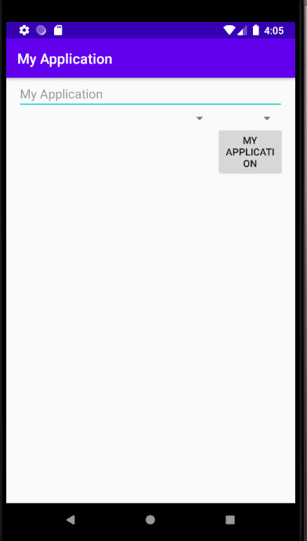

**(c) Grid Layout**

activity_main.xml:

<GridLayout xmlns:android="http://schemas.android.com/apk/res/android"

xmlns:tools="http://schemas.android.com/tools"

android:id="@+id/GridLayout1"

android:layout_width="wrap_content"

android:layout_height="wrap_content"

android:columnCount="3"

android:rowCount="3"

android:orientation="horizontal"

tools:context="com.example.lab7c.MainActivity" >

<Space />

<Button

android:id="@+id/button1"

android:layout_gravity="left|top"

android:text="@string/app_name" />

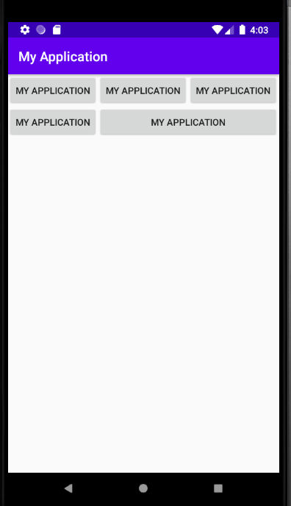

<Button

android:id="@+id/button3"

android:layout_gravity="left|top"

android:text="@string/app_name" />

<Button

android:id="@+id/button2"

android:layout_column="0"

android:layout_gravity="left|top"

android:layout_row="0"

android:text="@string/app_name" />

<Button

android:id="@+id/button4"

android:layout_column="0"

android:layout_gravity="left|top"

android:layout_row="2"

android:text="@string/app_name" />

<Button

android:id="@+id/button5"

android:layout_column="1"

android:layout_row="2"

android:layout_columnSpan="2"

android:layout_gravity="fill"

android:text="@string/app_name" />

</GridLayout>

**D) Table Layout:**

activity_main.xml:

<?xml version="1.0" encoding="utf-8"?>

<TableLayout xmlns:android="http://schemas.android.com/apk/res/android"

android:layout_width="match_parent"

android:layout_height="match_parent"

android:stretchColumns="1">

<TableRow>

<TextView

android:text="@string/app_name"

android:padding="3dip" />

<TextView

android:text="@string/app_name"

android:gravity="right"

android:padding="3dip" />

</TableRow>

<TableRow>

<TextView

android:text="@string/app_name"

android:padding="3dip" />

<TextView

android:text="@string/app_name"

android:gravity="right"

android:padding="3dip" />

</TableRow>

</TableLayout>

